**P3 - demonstrate the use of editing tools to edit and manipulate images**

**Introduction**

In this assignment, I will be demonstrating how I used the tools and manipulated it by using the image on Adobe Photoshop CS5.1. As you can see below, I used a laptop picture to complete this task. I will be presenting screenshots to prove I did this criterion.

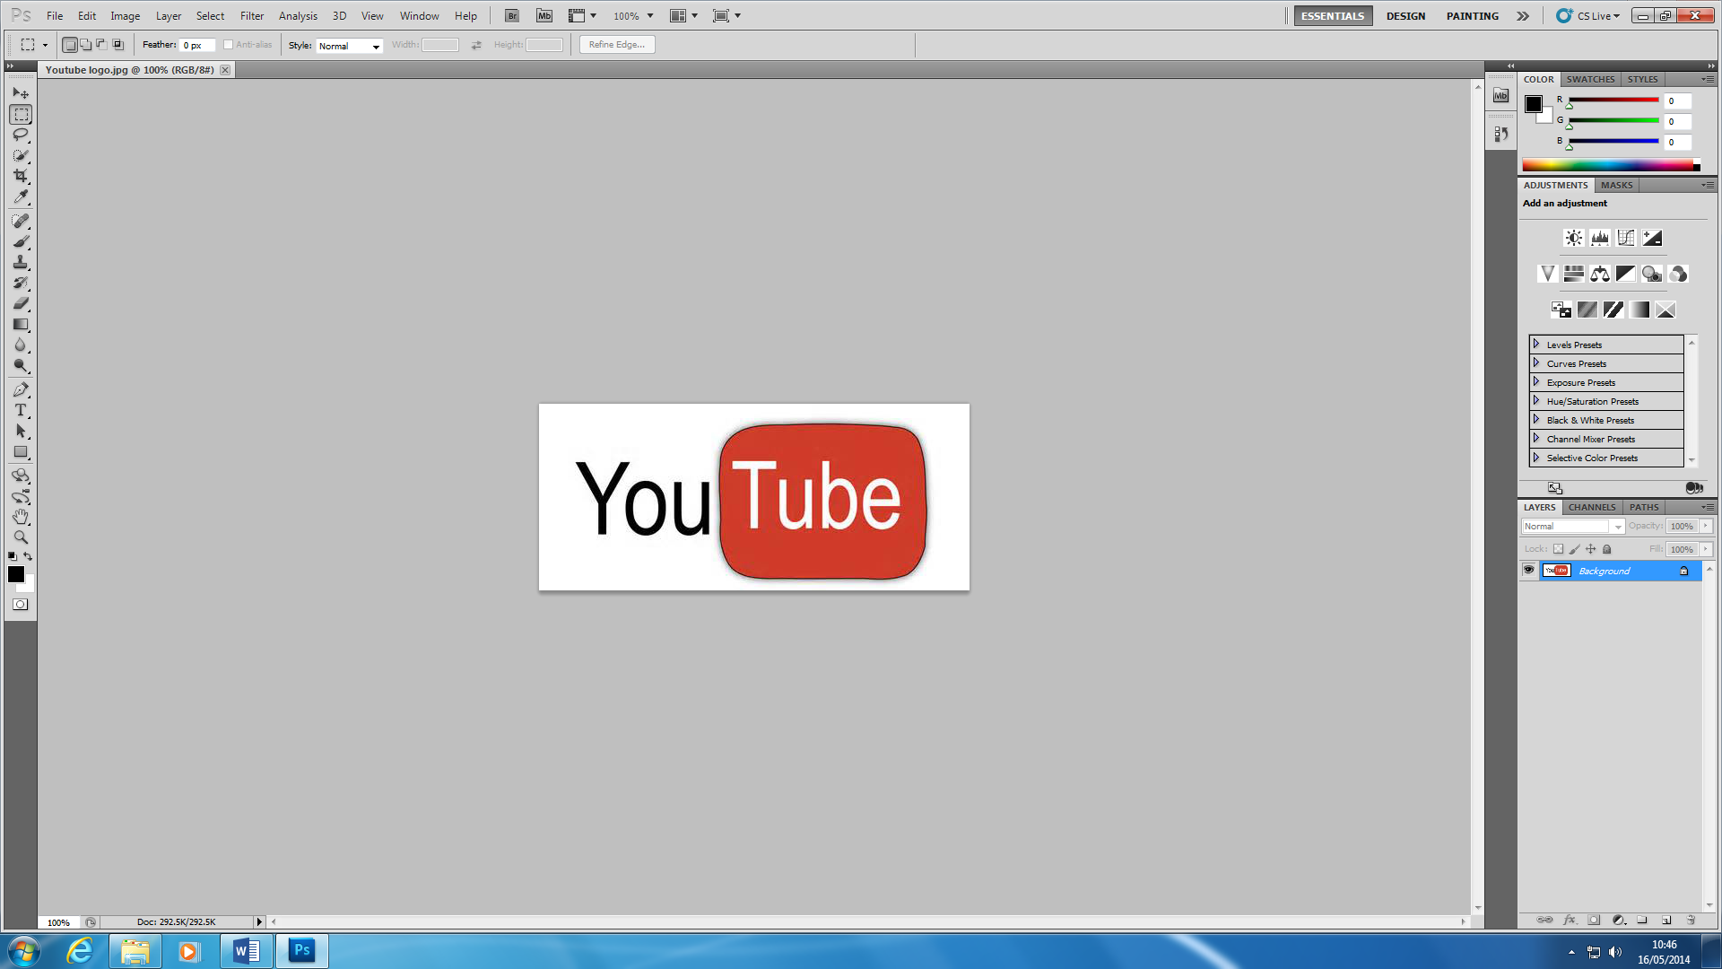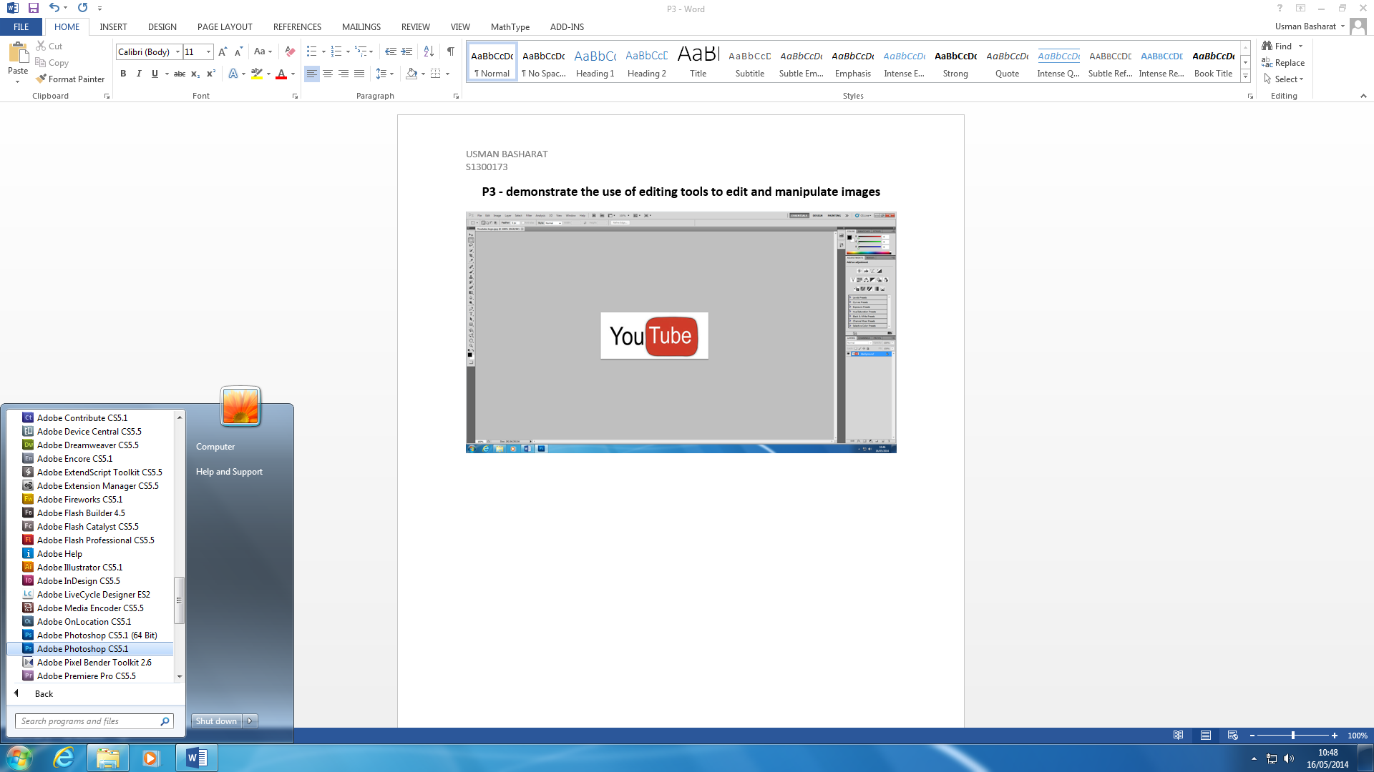Firstly, you need Adobe Photoshop CS5.1 to complete this task, as I would be using tools that cannot be found on any program. Once you have this software, you will need to open up your logo and program to get it working. You have to save your image to open it up. Therefore, it is important you save it in your area. Once you open your image, it will look something like the image below. If it is your first time using Photoshop, like me, you will need to fiddle with it to get used to the tools and select the tools that is suitable for you.

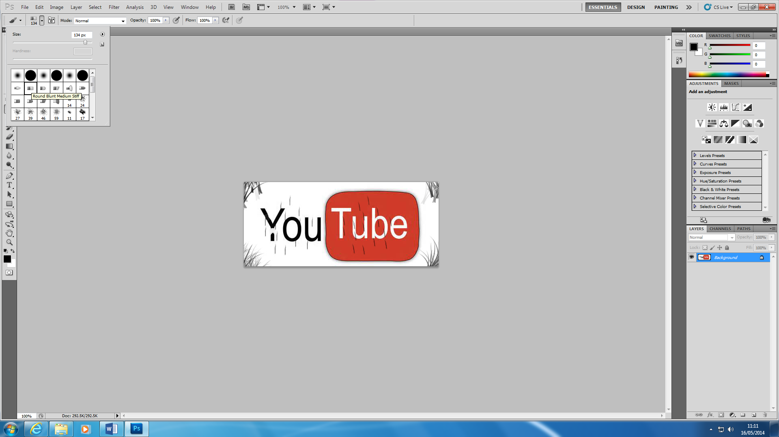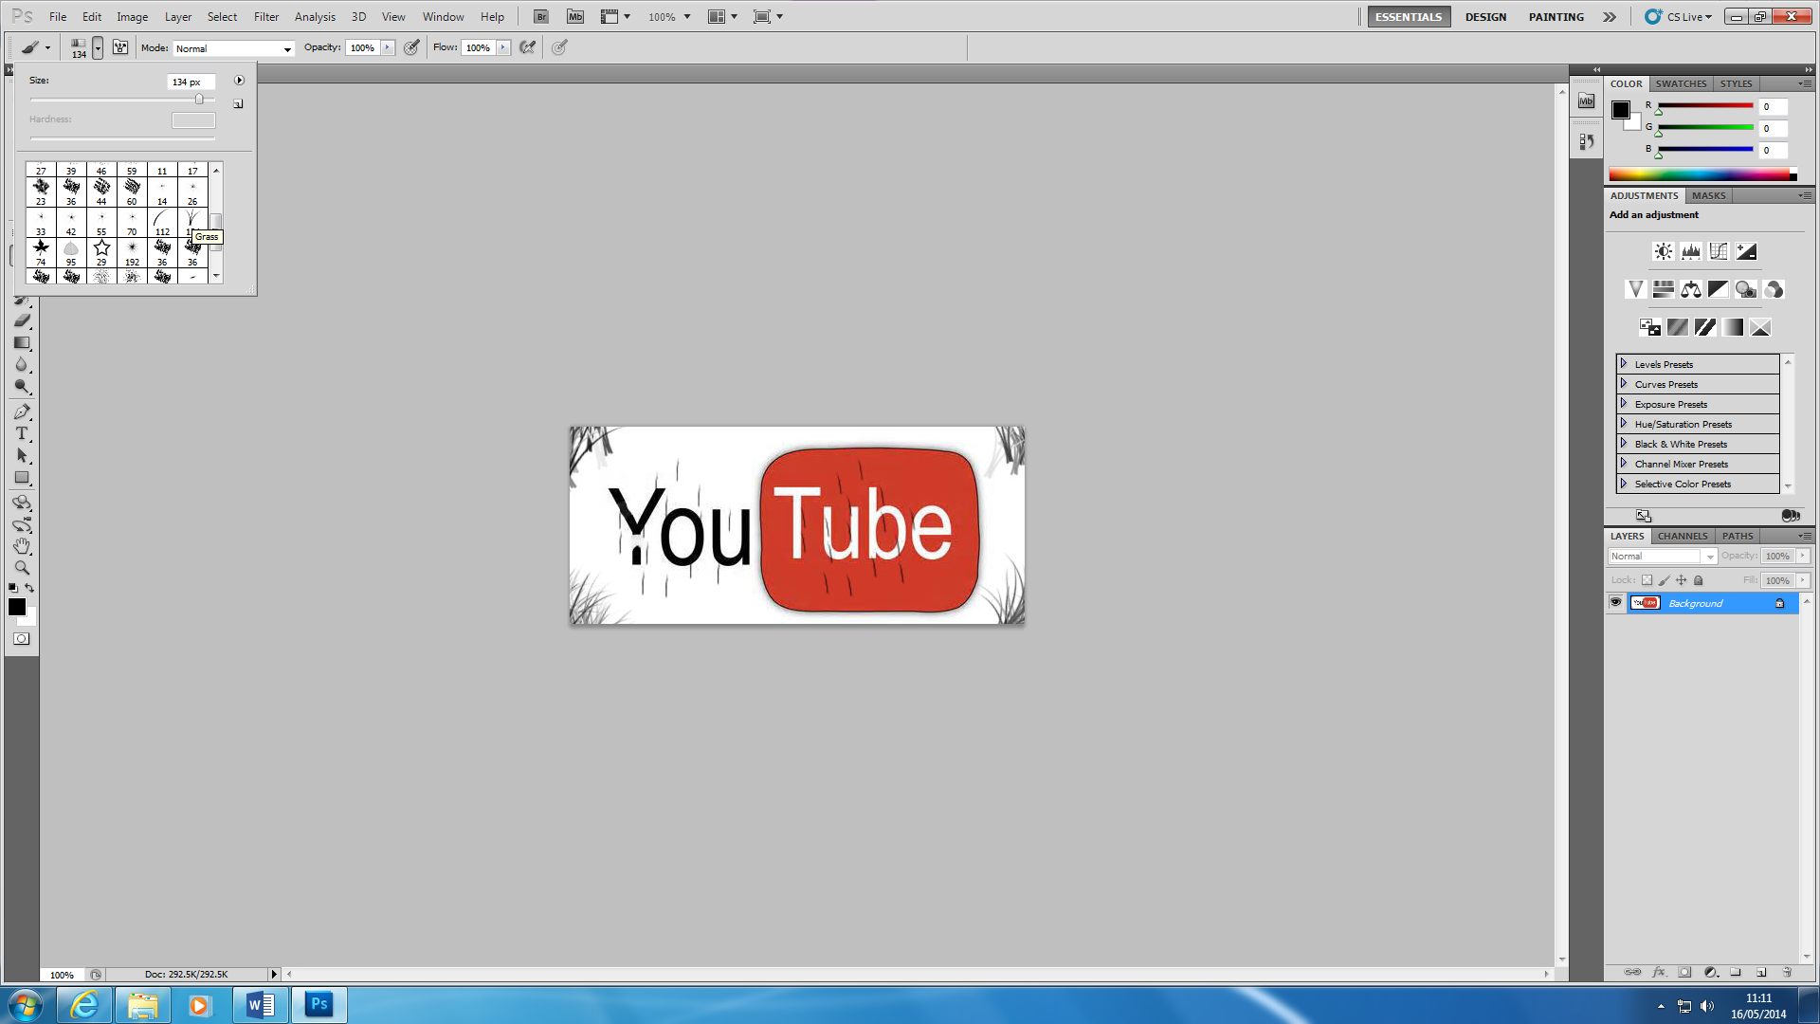I used many tools to create my new logo and the main one that I used is brush tool. I did not only use it, but they were advanced tools and the image below demonstrates how many tools they were. ‘Round Blunt Medium Stiff’ was one of the tools that created the scratch marks on the edges. I did this logo basic and I did not want to spend too much time on this logo. I did it basic, but if I were to make it good, I would take my time on it. I only took around 30 minutes to do this logo. Another tool that I used was ‘Grass’ and this created the brush edges of the logo.

These are the two logos and it shows how it has been done. As you can see the ‘little arrow’, it shows many more tools that can be used for the brush tool.

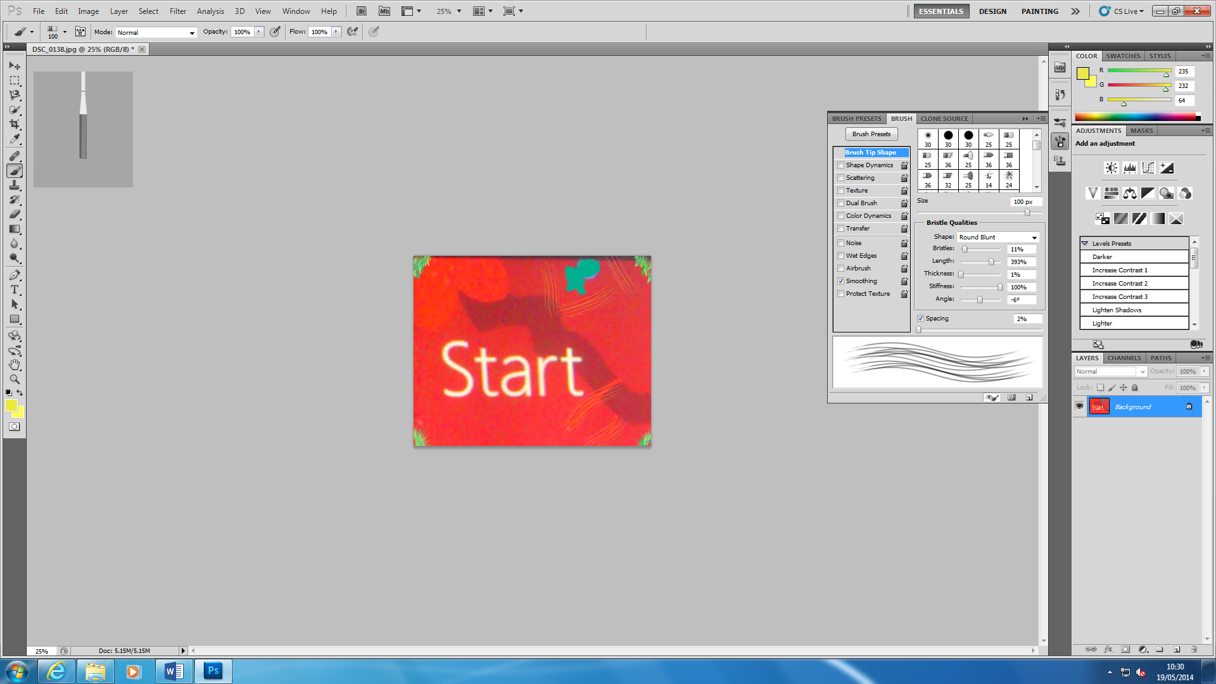This is the finished piece by using Adobe Photoshop. As you can see both of the tools that I explained before has been present on the logo.

This is the Round Blunt Medium Stiff tool and the “grass” edges are used as well.

The first step I took whilst completing this is that I opened the original version of the ‘Laptop’ logo. I did this by selecting by, “**File**”, and then locate to where you saved your image. Once you have completed this, you need edit the file by selecting the, “**brush file**”. As you can see below, the ‘little arrow’ gives us more tools that we can use. I used ‘Grass’ and ‘Round Blunt Medium Stiff’ tools. Once you are finished with it, you save it and you are finished. I used the grass tool for the edges and the round blunt tool for the scratches around the edges of the logo.

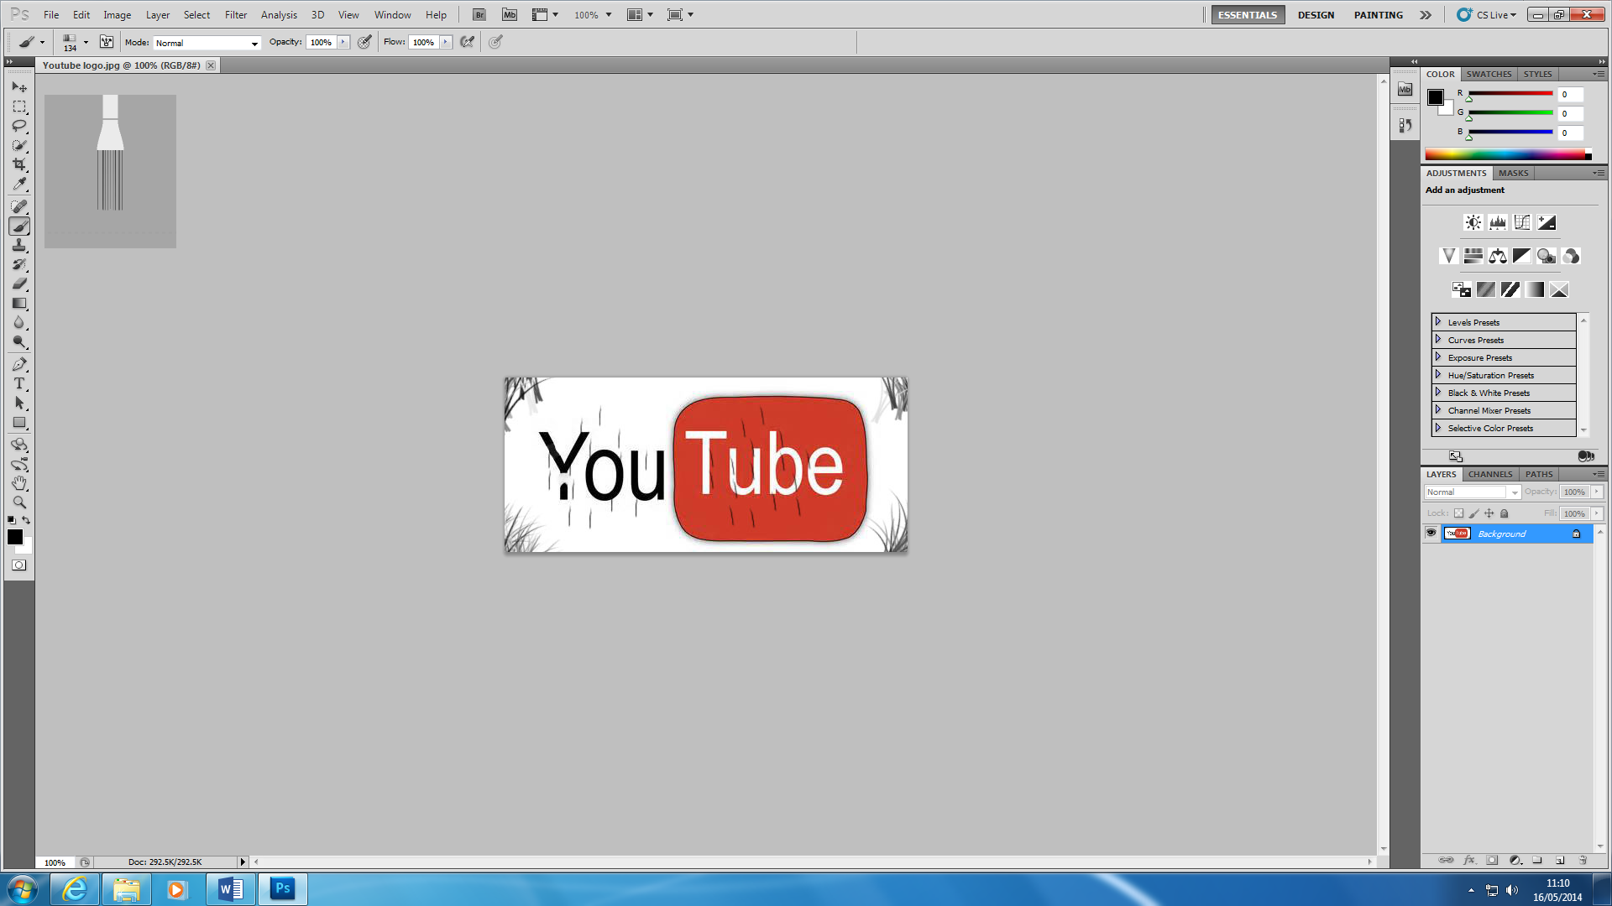

This is the original picture. I used this original picture and narrowed it down until I found the logo that I wanted. To make it as the picture above, I used the ‘Crop Tool’ to finish this task. I cropped it down till it says, “Start”. Before I did this, I changed the resolution and the contrast of the picture. As you can see on the images below, it shows the how I adjusted it.

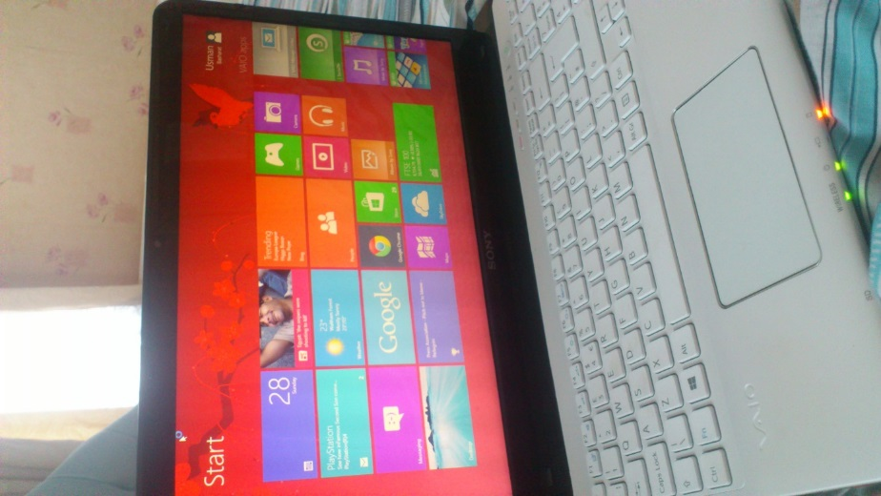

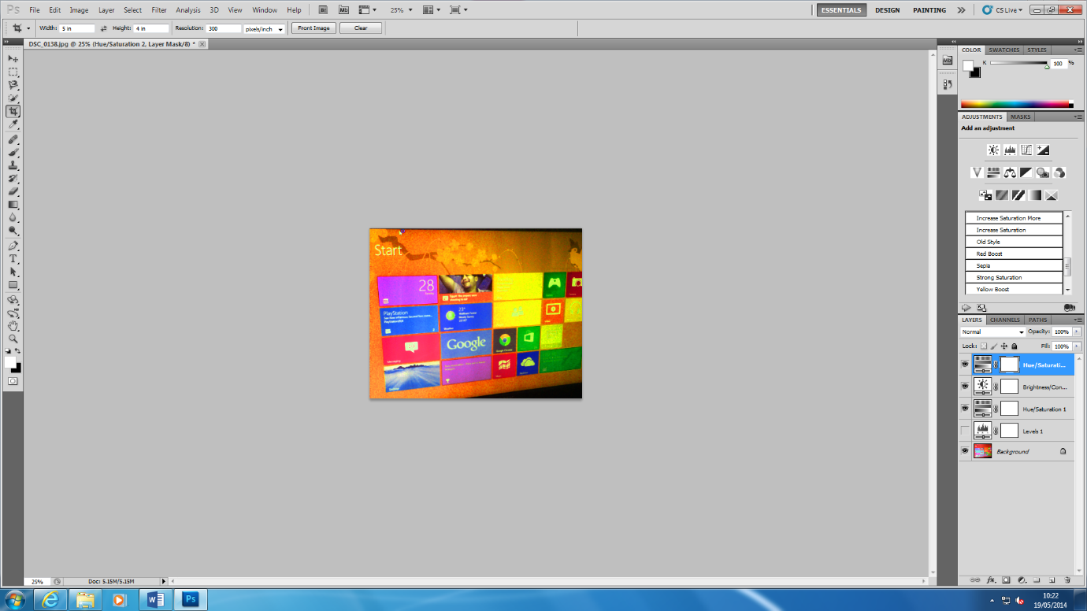

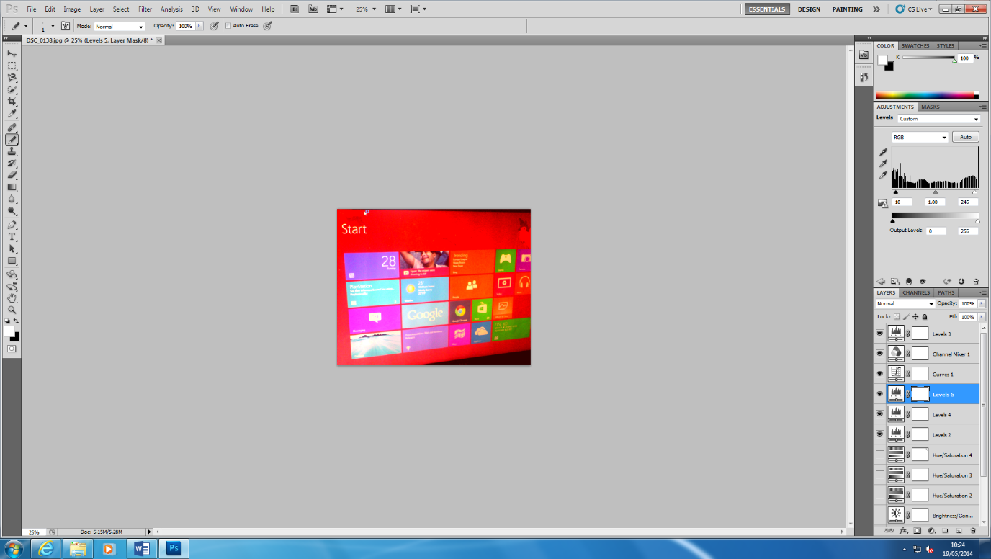

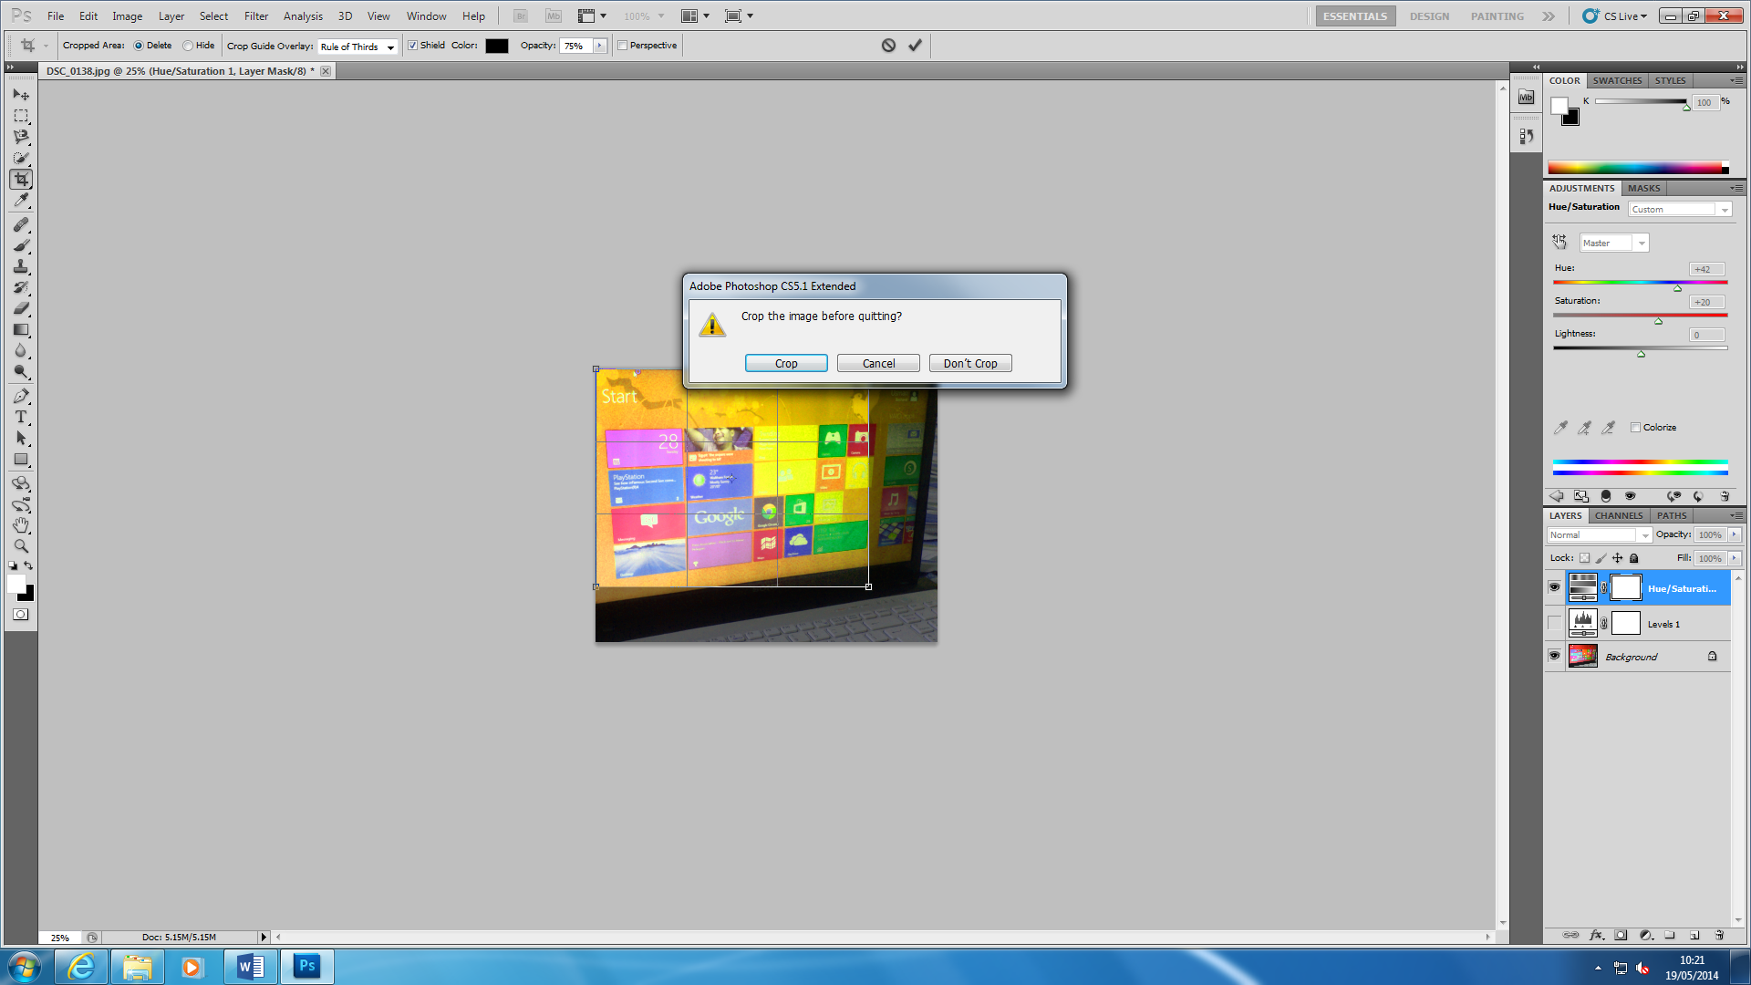

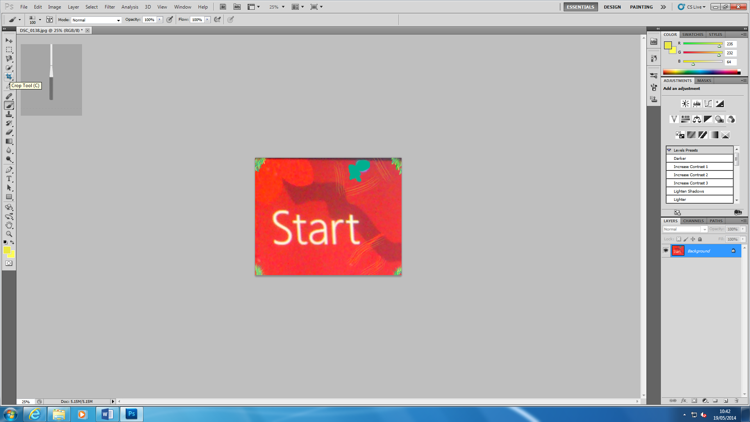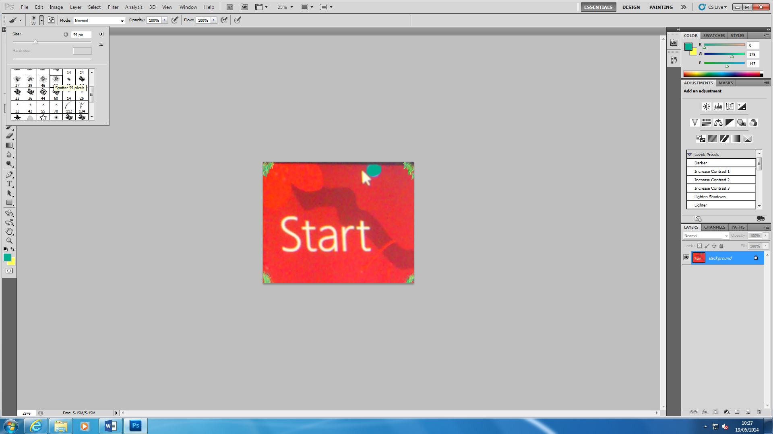I used the ‘Spatter 59 pixels’ tool to cover the ‘mouse’. It was the same place where I found the previous tools that I used before.